LAB MANUAL
of Subject
ESSENTIAL SKILLS OF INFORMATION TECHNOLOGY
Subject Code: 09CT0101

Student Name: Savaliya Meet A.
Enrollment No: 91900957053

Submission Date: 30/11/2019

Department of Information & Communication Technology
Faculty of Diploma Engineering


ESIT LAB

PRACTICAL INDEX

SR. NO. | TITLE | PAGE NO | DATE | SIGN
1 | HTML WEBSITE | 5
1.1 | Mainframe | 5
1.2 | Navigation | 6
1.3 | Header | 8
1.4 | Paragraphs | 9
1.5 | Lists | 10
1.6 | Tables | 11
1.7 | Image & Link | 12
1.8 | Form | 13
2 | CSS | 15
2.1 | Selectors | 15
2.2 | Borders | 17
2.3 | Text | 20
2.4 | Fonts | 22
2.5 | Multiple Columns | 24
3 | DOCUMENTATION | 27
3.1 | Result Spreadsheet | 27
SR. NO. | TITLE | PAGE NO | DATE | SIGN
4 | JAVASCRIPT | 28
4.1 | JavaScript Variables | 28
4.2 | Odd even example | 30
4.3 | Month Check Example | 31
4.4 | Lowest number check | 33
5 | SoloLearn HTML Course Certificate | 35
6 | SoloLearn CSS Course Certificate | 36
7 | SoloLearn JavaScript Course Certificate | 37
8 | Spoken Tutorials Certificate - Introduction to Computers | 38

STUDENT NAME: ________________________

STUDENT SIGN:

FACULTY SIGN: HOD SIGN:

PRACTICAL 1: HTML WEBSITE
Problem statement: Make a static website made in HTML.
Solution:
File 1.1: MainFrame
Code:
<html>
<frameset rows="25%,75%">
<frame src="Header.html"/>
<frameset cols="25%,75%">
<frame src="Navigation.html"/>
<frame src="" name="showframe"/>
</frameset>
</frameset>
</html>

Output: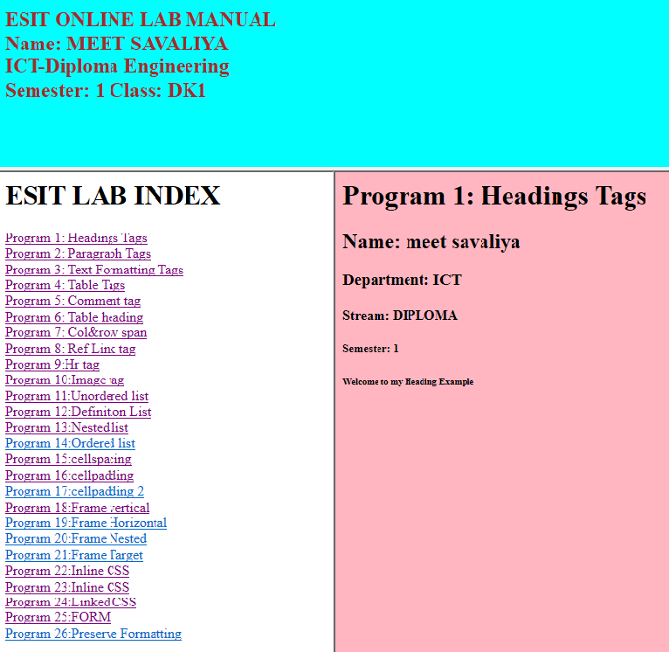
File1.2: Navigation
Code:

<html>
<body>
<h1> ESIT LAB INDEX</h1>
<a href="A.html" target="showframe"/>Program 1: Headings Tags</a>
<br/>
<a href="B.html" target="showframe"/>Program 2: Paragraph Tags</a>
<br/>
<a href="C.html" target="showframe"/>Program 3: Text Formatting Tags</a>
<br/>
<a href="D.html" target="showframe"/>Program 4: Table Tags</a>
<br/><a href="E.html" target="showframe"/>Program 5: Comment tag</a>
<br/>
<a href="F.html" target="showframe"/>Program 6: Table heading</a>
<br/>
<a href="G.html" target="showframe"/>Program 7: Col&row span</a>
<br/>
<a href="H.html" target="showframe"/>Program 8: Ref Link tag</a>
<br/>
<a href="I.html" target="showframe"/>Program 9:Hr tag</a>
<br/>
<a href="J.html" target="showframe"/>Program 10:Image tag</a>
<br/>
<a href="K.html" target="showframe"/>Program 11:Unordered list</a>
<br/>
<a href="L.html" target="showframe"/>Program 12:Definition List</a>
<br/>
<a href="M.html" target="showframe"/>Program 13:Nested list</a>
<br/>
<a href="N.html" target="showframe"/>Program 14:Ordered list</a>
<br/>
<a href="o.html" target="showframe"/>Program 15:cellspacing</a>
<br/>
<a href="P.html" target="showframe"/>Program 16:cellpadding</a>
<br/>
<a href="Q.html" target="showframe"/>Program 17:cellpadding 2</a>
<br/>
<a href="R.html" target="showframe"/>Program 18:Frame vertical</a>
<br/>
<a href="s.html" target="showframe"/>Program 19:Frame Horizontal</a>
<br/>
<a href="T.html" target="showframe"/>Program 20:Frame Nested</a>
<br/>
<a href="U.html" target="showframe"/>Program 21:Frame Target</a>
<br/>
<a href="V.html" target="showframe"/>Program 22:Inline CSS</a>
<br/>
<a href="W.html" target="showframe"/>Program 23:Inline CSS</a>
<br/>
<a href="X.html" target="showframe"/>Program 24:Linked CSS</a>
<br/>
<a href="Y.html" target="showframe"/>Program 25:FORM</a>
<br/>
<a href="Z.html" target="showframe"/>Program 26:Preserve Formatting</a>
<br/>
</body>
</html
Output:
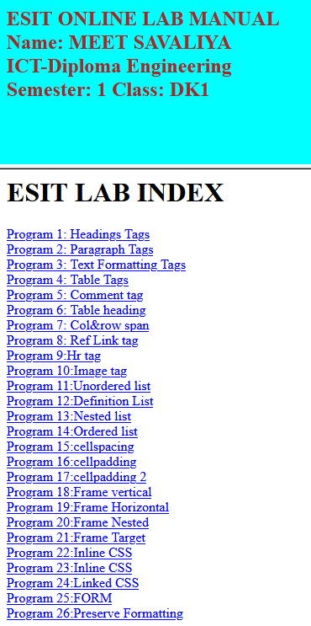
File1.3: Header
Code:

<html>
<frameset rows="25%,75%">
<frame src="Header.html"/>
<frameset cols="25%,75%">
<frame src="Navigation.html"/>
<frame src="" name="showframe"/>
</frameset>
</frameset>
</html>
Output:


File1.4: Paragraphs
Code:

<html>
<body bgcolor="skyblue">
<h1>Program 2: Paragraph Tags</h1>
<h2>Name: meet savaliya</h2>
<p align="justify">This is my paragraph 1 in Program 2.</p>
<p align="center">This is my paragraph 2 in Program 2.</p>
<p align="right">Enrollment No: 91900957053</p>
<p align="right">Semester: 1</p>
<p align="right">Class: DK1</p>
<p align="right">Course: Diploma</p>
<p align="right">Department: ICT</p> </body>
</html>
Output:
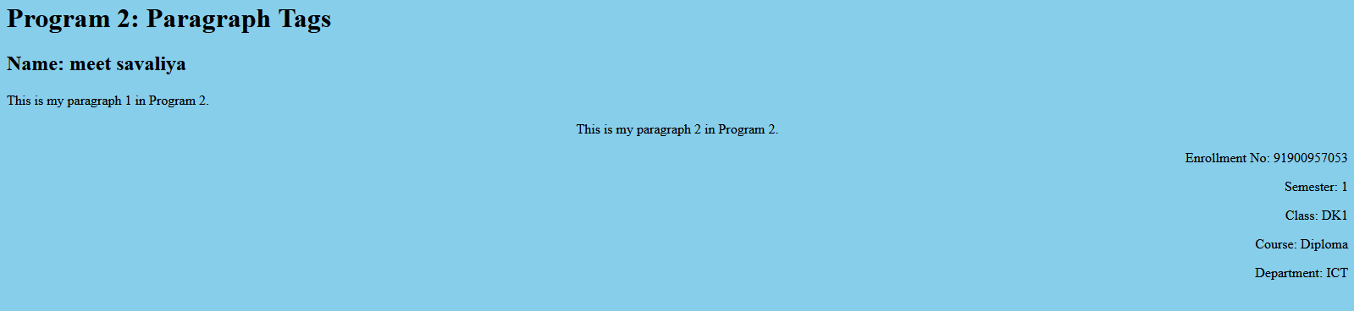
File1.5: List
Code:
<html>
<body bgcolor="lightblue">
<h4>An Unordered List:</h4>

Example – Disc using type attribute
<ul type="disc">
<li>Coffee</li>
<li>Tea</li>
</ul>
Example – Circle using type attribute
<ul type="circle">
<li>Coffee</li>
<li>Tea</li>
</ul>
</body>
</html>
Output:
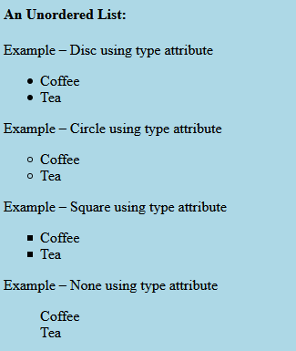

File1.6: Table
Code:
<html>
<body bgcolor="lightpink">

<h1>Program 4: Table Tags</h1>
<table border="3">
<tr>
<th>Enrollment No</th>
<th>Name</th>
<th>Semester</th>
<th>Department</th>
<th>Course</th>
<th>Class</th>
</tr> <tr>
<td>91900957053</td>
<td>meet savaliya</td>
<td>1</td>
<td>ICT</td>
<td>Diploma</td>
<td>DK1</td>
</tr> </table>
</body>
</html>
Output:
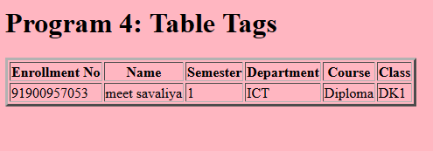

File1.7: Image & Link
Code:
<html>
<body>
<img src="https://www.google.com/images/branding/googlelogo/1x/googlelogo_color_272x92dp.png" alt="google" height="250" width="300"/>
<h3>
<a href="https://www.google.com//">This is a link to Google</a>
</h3>
</body>
</html>
Output:


File1.8: Form
Code:

<html>
<body>
<center>

<form action="" method="GET">
<table border="1">
<tr>
<td> First Name: </td>
<td><input type="text" name="firstname"/></td>
</tr>
<tr>
<td> Last Name: </td>
<td><input type="text" name="lastname"/></td>
</tr>
<tr>
<td> Username: </td>
<td><input type="text" name="user"/></td>
</tr>
<tr>
<td> Password: </td>
<td><input type="password" name="password"/></td>
</tr>
<tr>
<td> Language : </td>
<td>
<input type="checkbox" name="lang" value="Guj"/>Gujarati
<input type="checkbox" name="lang" value="Hin"/>Hindi
<input type="checkbox" name="lang" value="Eng"/>English
</td>
</tr>
<tr>
<td> Gender: </td>
<td><input type="radio" name="sex" value="male"/>Male
<input type="radio" name="sex" value="female"/>Female
</td>
</tr>
<tr>
<td> City: </td>
<td>
<select name="city">
<option value="ahmedabad">Ahmedabad</option>
<option value="rajkot">Rajkot</option>
<option value="bhavnagar">Bhavnagar</option>
</select>
</td>
</tr>
<tr>
<td> Address: </td>
<td><textarea rows="5" cols="17"></textarea></td>
</tr>
<tr>
<td> Upload Photo: </td>
<td><input type="file"/></td>
</tr>
<tr>
<td></td>
<td><input type="submit" value="Register"/>
<input type="reset" value="Reset"></td>
</tr>
</table>
</form>
</center></body>
</html>
Output:
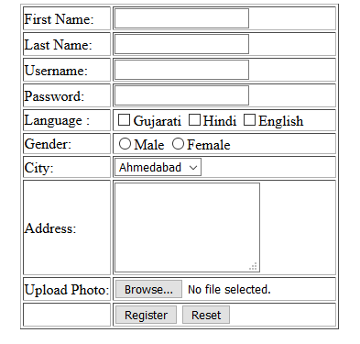

PRACTICAL 2: CSS

File2.1: CSS Selectors
Sample Code:
<html>
<head>
<style>
body{background-color: lightblue;border: 3px double;text-shadow:2px 2px black;}
*{text-align:center;color:#ff5050;font-family:Lucida Handwriting;font-size:30px;}
p{text-align:justify;color:blue;font-family:Mistral;background-color: Violet;font-size:40px;border: 3px outset red;text-shadow:1px 2px red;}
h1,h2{text-align:center;color:red;font-family:Magneto;font-size:40px;border:inset 3px blue;background-color:lightblue;}
table,tr,td,th{border:dotted 3px red;}.p2{background-color:red;}
.h3,.h4,.h5,.h6{text-align:right;color:red;font-family:Segoe Script;text-shadow:1px 2px black}
#t3,tr3,td3,th3{border:dashed 4px blue;}
</body>
</html>
Output:
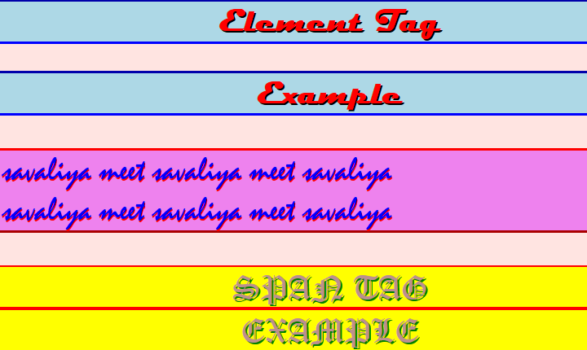
File2.2: CSS Borders
Sample Code:
<html>
<body>
<p style="background-color:lightblue; border-style:dotted;border-radius: 12px; ">

<br>Name: Meet Savaliya</br>
<br>Enrollment no:91900957053</br>
<br>Department: ICT</br>
<br>Stream: DIPLOMA</br>
<br>Semester: 1</br>
<br>Border Style: Dotted line </br>
</p></br>
</body></html>

Output:

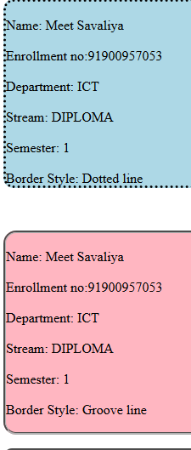 | 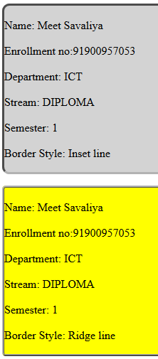
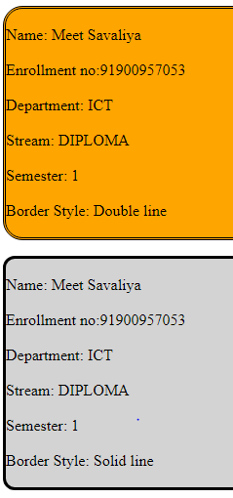 | 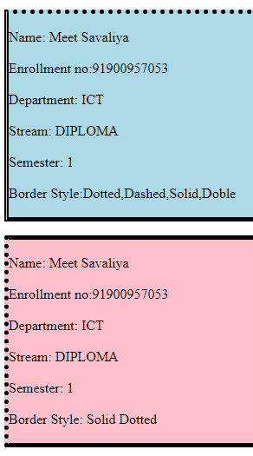

File2.3: CSS Text
Sample Code:
<html>
<head>
<style>
.x{text-decoration:overline;word-spacing:-5px;text-align:left;letter-spacing:3px;text-transform:uppercase;text-shadow:3px 2px blue;color:red;text-indent:100px;line-height:30px;}
.y{text-decoration:underline;word-spacing:5px;;text-align:right;letter-spacing:-1px;text-transform:lowercase;text-shadow:3px -4px green;color:red;text-indent:80px;line-height:40px}
.z{text-decoration:line-through;word-spacing:7px;;text-align:center;letter-spacing:5px;text-transform:capitalize; color:#026894;line-height:-25px}
.a{text-decoration:overline;word-spacing:-3px;;text-align:justify;letter-spacing:4px;text-transform:uppercase;color:red;line-height:20px}
</style>
</head>
<body bgcolor="lightpink";>
<p class="x">name:savaliya meet, roll no:91900957053,branch: ICT,semester:1.name:savaliya meet, roll no:91900957053,branch: ICT,semester:1.
</p></br>
<p class="y">name:savaliya meet,roll no:91900957053, branch: ICT, semester:1.name:savaliya meet,roll no:91900957053, branch: ICT, semester:1.name:savaliya meet,roll no:91900957053, branch: ICT, semester:1
</p></br>
<p class="z">name:savaliya meet,roll no:91900957053, branch: ICT, semester:1.name:savaliya meet,roll no:91900957053, branch: ICT, semester:1.name:savaliya meet,roll no:91900957053, branch: ICT, semester:1.name:savaliya meet,roll no:91900957053, branch: ICT, semester:1.name:savaliya meet,roll no:91900957053, branch: ICT,semester:1.
</p></br>
<p class ="a">name:savaliya meet,roll no:91900957053, branch: ICT, semester:1.name:savaliya meet,roll no:91900957053, branch: ICT, semester:1.name:savaliya meet,roll no:91900957053, branch: ICT, semester:1.name:savaliya meet,roll no:91900957053, branch: ICT, semester:1.name:savaliya meet,roll no:91900957053, branch: ICT,semester:1.
</p></br>
</body></html>
Output:
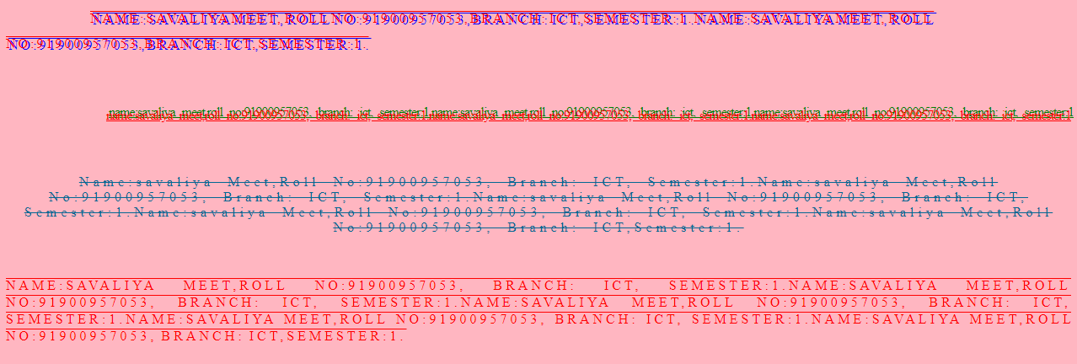

File2.4: CSS Font
Sample Code:
<html>
<body>
<p style =" border:10px solid black;background-color: lightblue;padding: 10px;margin: 50px; outline:#4CAF50 dashed 5px; outline-offset:5px;text-align: center;text-decoration: line-through;text-transform: capitalize;font-family:serif;">
name: Meet Savaliya
enrollment no:91900957053
semester:1
department:ICT
</p>
<p style =" border:5px dashed black;background-color: lightyellow;padding : 10px;margin: 50px; outline:#4CAF50 solid 5px; outline-offset:5px;text-align:justify;text-decoration: overline;font-family:sansserif;font-size:2vw ;">
name: Meet Savaliya
enrollment no:91900957053
semester:1
department:ICT
</p>
<p style =" border:10px ridge black;background-color: lightpink;padding-top: 10px;margin-bottom: 10px; outline:#4CAF50
groove 5px; outline-offset:5px;text-decoration: underline;letter-spacing: 3px;font-family:Times;">
name: Meet Savaliya
enrollment no:91900957053
semester:1
department:ICT
</p>
<p style =" border:10px double black;background-color: lightgrey;;padding-left: 50px;margin: 50px; outline:#4CAF50 ridge 5px; outline-offset:5px;text-transform: lowercase;font-family:Courier New;">
name: Meet Savaliya
enrollment no:91900957053
semester:1
department:ICT
</p>
<p style =" border:5px dotted black;background-color: lightblue;padding-top: 10px;margin: 50px; outline:#4CAF50 ridge 5px; outline-offset:5px;text-indent: 50px; font-style: italic;">
name: Meet Savaliya
enrollment no:91900957053
semester:1
department:ICT

Output:
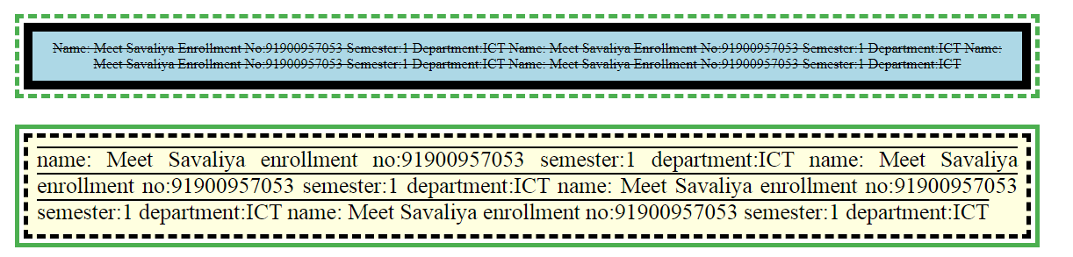
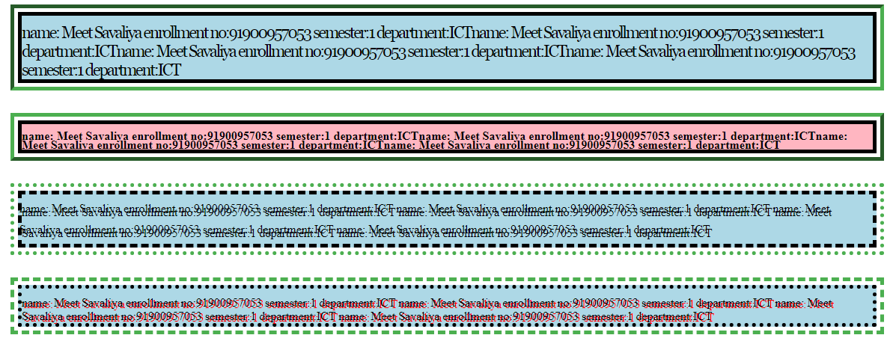

File2.4: CSS Multiple Columns
Sample Code:
<html><head>
<style>
.x{text-decoration:overline;word-spacing:-5px;text-align:left;letter-spacing:3px;text-transform:uppercase;text-shadow:3px 2px blue;color:red;text-indent:100px;line-height:30px;
column-count: 5; column-rule: 4px outset red;column-span:all;
column-gap:70px;
}

.y{text-decoration:underline;word-spacing:5px;;text-align:right;letter-spacing:-1px;text-transform:lowercase;text-shadow:3px -4px green;color:red;text-indent:80px;line-height:40px;
column-count: 5; column-rule: 4px outset red;column-span:all;
column-gap:40px;}
.z{text-decoration:line-through;word-spacing:7px;;text-align:center;letter-spacing:5px;text-transform:capitalize; color:#026894;line-height:-25px;column-count: 5; column-rule: 4px outset red;column-span:all;
column-gap:40px;}
.a{text-decoration:overline;word-spacing:-3px;;text-align:justify;letter-spacing:4px;text-transform:uppercase;color:red;line-height:20px;column-count: 5; column-rule: 4px outset red;column-span:all;
column-gap:40px;}
</style>
</head>
<body bgcolor="lightpink";>
<p class="x">name:savaliya meet<br>
roll no:91900957053<br>
branch: ICT<br> semester:1<br> name:savaliya meet<br> roll no:91900957053<br> branch: ICT<br> semester:1<br>
name:savaliya meet<br>
roll no:91900957053<br>
branch: ICT<br> semester:1<br> name:savaliya meet<br> roll no:91900957053<br> branch: ICT<br> semester:1<br>
</p></br>
<p class="y">name:savaliya meet<br>
roll no:91900957053<br>
branch: ICT<br>
semester:1<br>
name:savaliya meet<br>
roll no:91900957053<br>
branch: ICT<br>
semester:1<br>
name:savaliya meet<br>
roll no:91900957053<br>
branch: ICT<br>
semester:1<br>
</p></br>
<p class="z">name:savaliya meet<br>
roll no:91900957053<br>
branch: ICT<br>
semester:1<br>
name:savaliya meet<br>
roll no:91900957053<br>
branch: ICT<br>
semester:1<br>
name:savaliya meet<br>
roll no:91900957053<br>
branch: ICT<br>
semester:1<br>
</p></br>

<p class ="a">name:savaliya meet,roll no:91900957053, branch: ICT, semester:1.name:savaliya meet,roll no:91900957053, branch: ICT, semester:1.name:savaliya meet,roll no:91900957053, branch: ICT, semester:1.name:savaliya meet,roll no:91900957053, branch: ICT, semester:1.name:savaliya meet,roll no:91900957053, branch: ICT,semester:1.
</p></br>
</body></html>

Output:
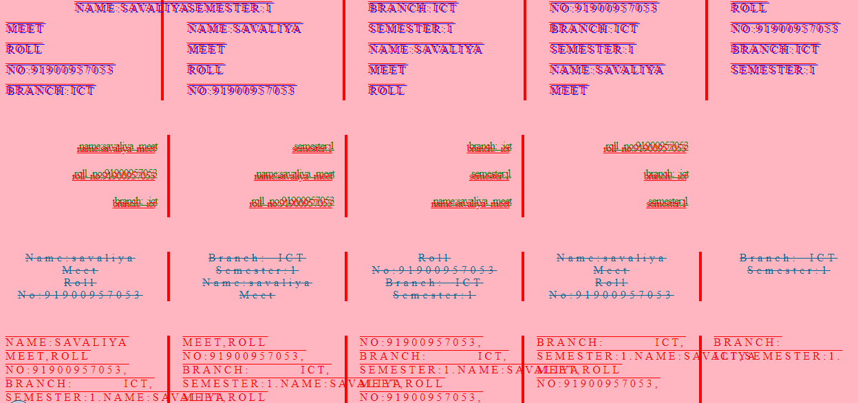

PRACTICAL 3: DOCUMENTATION

File3.1: Result Spreadsheet

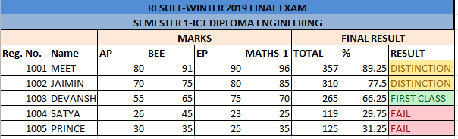

PRACTICAL 4: JavaScript

File4.1: JavaScript Variables
Sample Code:
<html>
<body>
<h2>JavaScript Variables</h2>
<p id="demo"></p>
<script>
var x ="John" + " " + "Doe";
document.getElementById("demo").innerHTML = x;
</script>
<p>The result of adding 2 + 3 + "5":</p>
<p id ="demo2"></p>
<script>
var x = 2 + 3 + "5";
document.getElementById("demo2").innerHTML = x;
</script>
<p id ="demo3"></p>
<script>
var x = 5 + 5;
var y = "5" + 5;
var z = "Hello"+5;
document.getElementById("demo3").innerHTML =
x + "<br>" + y + "<br>" + z;
</script>
</body></html>
Output:

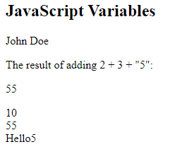

File4.2: JavaScript Odd And Even
Sample Code:
<html>
<body>
<h2>JavaScript Odd Even Example</h2>
Number 1: <input type="text" id="n1" name="n1"/>
</br>
<input type="button" value="Check Odd / Even" onclick="check()"/>
<script>

function check()
{

a = parseInt(document.getElementById("n1").value);
if (a%2==0)
{
alert("even number")
}
else
{
alert("odd number")
}
}
</script>
</body>
</html>

Output: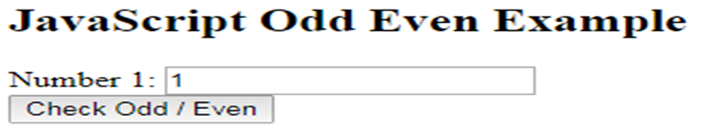

File4.3: JavaScript Month Example
Sample Code
<html> <body>
<h2>JavaScript Switch Case Example</h2>
Enter your Month: <input type="text" id="grade"/> <br/>
<input type="button" value="Check" onclick="getResult()" />
<script>
function getResult() {
var grade=document.getElementById("grade").value;
var result;
switch(grade) {
case '1':
result = "January";
break;
case '2':
result = "Feruary";
break;
case '3':
result = "March";
break;
case '4':
result = "April";
break;
case '5':
result = "May";
break;
case '6':
result = "June";
break;
case '7':
result = "July";
break;
case '8':
result = "August";
break;
case '9':
result = "September";
break;
case '10':
result = "October";
break;
case '11':
result = "November";
break;
case '12':
result = "December";
break;
default:
result ="No Grade"
}
alert("Month is: " + result);
}
</script>
</body>
</html>

Output:

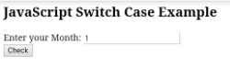

File4.4: JavaScript lowest number check
Sample Code

<html>
<body>
<h2>JavaScript Odd Even Example</h2>
a: <input type="text" id="n1" name="n1"/>
</br>
b: <input type="text" id="n2" name="n2"/>
</br>
c: <input type="text" id="n3" name="n3"/>
</br>
<input type="button" value="Check lowest number" onclick="check()"/>

<script>

function check()
{

var a = parseInt(document.getElementById("n1").value);
var b = parseInt(document.getElementById("n2").value);
var c = parseInt(document.getElementById("n3").value);
if(a<b && a,b)
{
alert("a is lowest number");
}
else if (b<a && b<c)
{
alert("b is lowest number");
}
else
{
alert("c is lowest number");
}
}
</script></body></html>

Output:

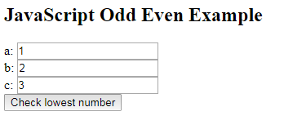
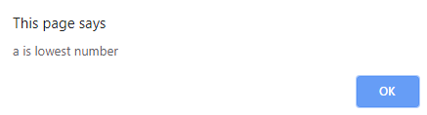

PRACTICAL 5: SoloLearn HTML Course Certificate



PRACTICAL 6: SoloLearn CSS Course Certificate



PRACTICAL 7: SoloLearn JavaScript Course Certificate


PRACTICAL 8: Spoken Tutorial Certificate - Introduction to Computer


